Friday, 5th July
7:00pm

Tickets
£ 12.00
including
Fish & Chip
supper

Raffle

Target team size 6

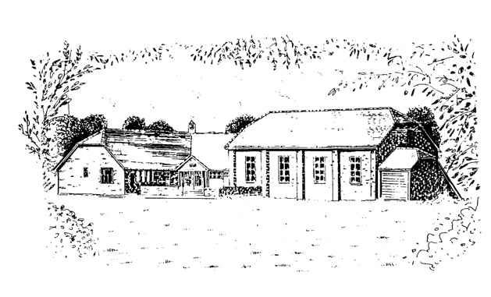

At
The Ark
Mount Lane
Turners Hill
RH10 4RA

