**Mid Sussex Conservatives Association**

**Invites you to a**

**Celebratory evening hosted by   
Sir Nicholas Soames MP   
to say thank you to   
Valerie & Ginny**

**Friday 12th July 2019 7pm – 10pm at**



**Foxhole Lane, Haywards Heath, West Sussex, RH17 5NB**

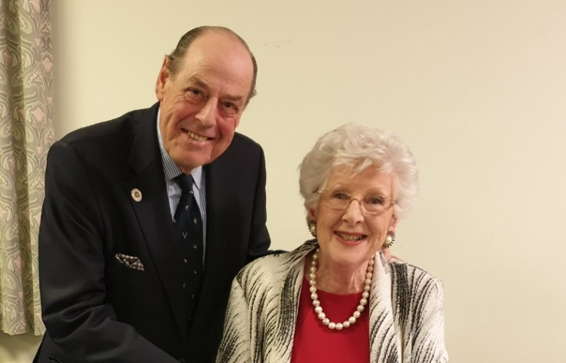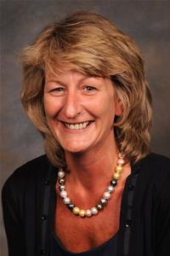

**Award winning English Sparkling Wine and a delicious Buffet Supper**

**Tickets £38**

WB01390_

Please reserve me \_\_\_\_\_\_ ticket(s) @ £38 each for the “Thank you” on 12th July 2019.   
(Please make cheques payable to ‘Mid Sussex Conservatives Association).

BACS payments: Mid Sussex Conservatives Association

Barclays Bank plc Sorting Code 20-49-76 Account Number: 70584568 Reference: BET/surname

Name: Mr/&/Mrs/Miss/Other \_\_\_\_\_\_\_\_\_\_\_\_\_\_\_\_\_\_\_\_\_\_\_\_\_\_\_\_\_\_\_\_\_\_\_\_\_\_\_\_\_\_\_\_\_\_\_\_\_\_\_\_

Address: \_\_\_\_\_\_\_\_\_\_\_\_\_\_\_\_\_\_\_\_\_\_\_\_\_\_\_\_\_\_\_\_\_\_\_\_\_\_\_\_\_\_\_Postcode: \_\_\_\_\_\_\_\_\_\_\_\_\_\_\_­­­­­\_\_

Email: \_\_\_\_\_\_\_\_\_\_\_\_\_\_\_\_\_\_\_\_\_\_\_\_\_\_\_\_\_\_\_\_\_\_\_\_ Tel No: \_\_\_\_\_\_\_\_\_\_\_\_\_\_\_\_\_\_\_\_\_\_\_\_\_

There will be no tickets issued but your name will be on an attendance list.

Please return to, MSCA, 5 Hazelgrove Road, Haywards Heath, West Sussex RH16 3PH  
Promoted, printed & Published by Claire Fussell on behalf of the Mid Sussex Conservatives Association, 5 Hazelgrove Road, Haywards Heath, West Sussex. RH16 3PH